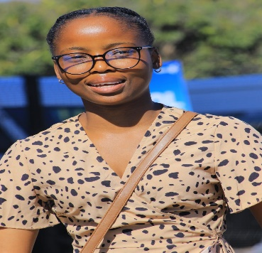

CANDIDATE

SEIPATI NERIA RIBA

RESUME

# Personal Details

**Date of Birth:**

03 August 2003

**Residential Area:**

Braamlofts Campus Africa

24 Biccard Street

Johannesburg 2001

**Languages:**

Sepedi, English

# Education

Last attended: Raowele Secondary School

Highest grade past: 12

Year obtained: 2021

# Online Presence

<https://www.linkedin.com/in/riba-seipati-23424b243>

# Key **Skills**

Computer literacy: Microsoft office word, excel, power point and mastering the keyboard.

Good telephone etiquette

Highly skilled in office administration and good communication skills

# Interests & Hobbies

Volunteering in day cares, learning languages, and gardening

# About me

I’m an experienced joiner with developed skills and experience in office administration and I have worked in Godwin Masibe Primary School for 10 Months as an administrator and technical supporter with excellent time management skills, used to working in a team whilst also using own initiative. I’m enthusiastic to learn and undertake new challenges.

# Achievements & Key Projects

August 2022-February 2023

Administration at Godwin Masibe Primary School

April 2022-May 2022

Facilitated high school learners around Mapela on Making Hydrogen powered Lego vehicles.

# Work Experience

Godwin Masibe

Teacher Assistant

February 2023- March 2023

Anglo American

Technical Support & Computer Literacy

February 2022-February 2023

CapaCiTi

System Developer

March 2023-Present

# References

Contact Person: Kefiloe Mphye

Contact No: 081 334 8416

Email: [kefiloe.mphye@capaciti.org.za](mailto:kefiloe.mphye@capaciti.org.za)

Contact person: Busi Zindela

Contact No: 071 756 5450

Email: [busi.zindela@angloamerican.com](mailto:busi.zindela@angloamerican.com)

Contact Person: Itumeleng Mongatane

Contact No: 076 246 0047

Email: [itumelengmongatane97@gmail.com](mailto:itumelengmongatane97@gmail.com)